|  |  |  |  |  |
| --- | --- | --- | --- | --- |
| Monday | Tuesday | Wednesday | Thursday | Friday |
|  |  |  |  |  |
|  |  |  |  |  |
|  |  |  |  |  |
|  |  |  |  |  |

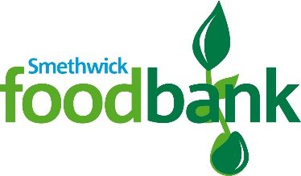**Reverse Advent Calendar 2020**

This has been the busiest year ever for Smethwick Foodbank and we’d really appreciate your support of our Christmas 2020 Reverse Advent Appeal.

Why not get together at work, as a family or with neighbours to do our Advent collection over the next four weeks.

Keep a check on our website, Facebook and Twitter for more suggestions on what to donate and to keep up to date with all we are doing!

Twitter: @smethwickfoodba

Facebook: Smethwick Foodbank

Website: smethwick.foodbank.org.uk

Drop off your donation w/c 7th December to:

Smethwick Foodbank, Holy Trinity Church, Church Hill Street, Smethwick, B67 7AH.

Email [foodbank@smethwickcan.org](mailto:foodbank@smethwickcan.org) or call 0121 517 0141 to arrange a time.

Thank you!

For other ways to make a donation, see our website:

https://smethwick.foodbank.org.uk/give-help/donate-money/